Final project Diploma of Software Engineering and Design 2016
MarketPlaces – a website designed to register, track and follow markets and their stall holders

Provocation:
The Pluralsight video training series, by Mosh Hamedani, on Becoming a Full-stack .NET Developer followed the idea of creating a website as a way of creating and tracking music gigs for artists and giving ways for fans to follow them. This gave me the idea of adapting it to create a similar idea for markets as my cousin is a stall holder and goes to different markets and, at times, I would like to know where I might find him.
I talked to him about my idea and he was very excited – his comment was “Do it!”, as the only way they now have to find out about markets is from other stall holders.
He would like to be able to search for markets within a specific region e.g.Canterbury, to check which days markets are operating and so be able to maximise time, and to be able to register online, thus enabling him to be able to plan ahead better.

The objective of this project, therefore, is to create a web site which would, eventually,:
- Allow an organizer/organization to register a planned market – with the ability to edit details or cancel a previously registered (by them) market.
- Show all markets registered.
- Show the details of the selected market. i.e. Date, Day of week, Area, Type of market, frequency e.g. weekly, monthly, yearly, etc
- Be able to search markets by area and to display general details of markets within a specific area.
- Allow selection of a listed market.
- ‘Details’ page will contain contact details of organizer and …
- ..a link to a ‘register’ page which would allow online registration, give information about fees and payment options for those fees
- Stall holders will be able to register for specific markets – either by following a link or by contacting the organizer offline.
- Once registered, stall holders would have access to further pages which give information on set up times and access, car parking availability, site information and site map.
- The market ‘detail’ view will then display which stalls are registered as part of the details
- Stall holders will be able to keep a record of which markets they have registered for via a drop down list, once they have logged in
- Market attendees/customers will be able to ‘follow’ a specific stall holder – in the case that they specifically want some of their products.
- Have a search/find facility to look for specific stall holders or products

To create this:
Process:
I have been working through the modules of the video series ‘Becoming a Full-stack .NET Developer’, making adjustments to accommodate my requirements as I went.
The first step for the project was to extract the core use statements and create a user story for which I used the VisualStudioOnline resource.
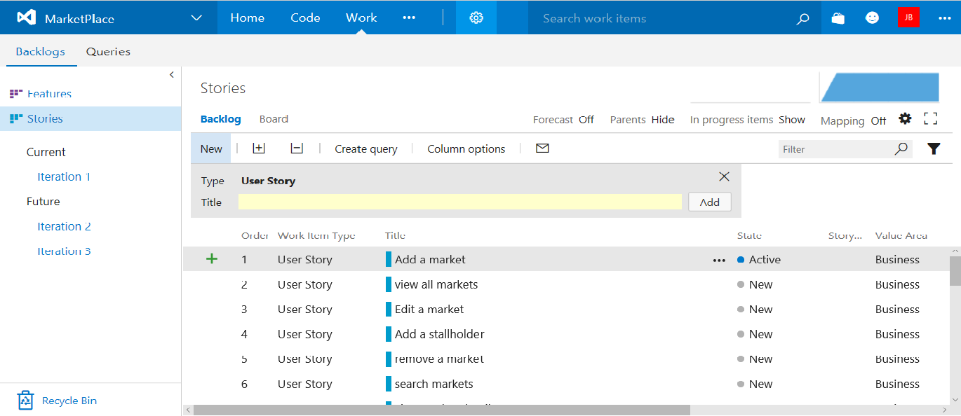
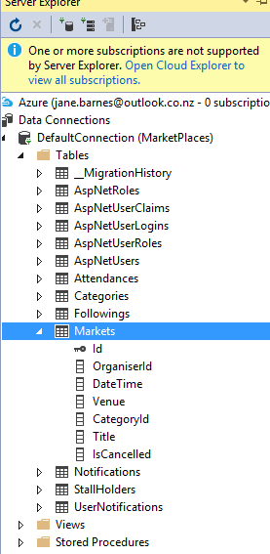
Then, using ASP.Net Core, I began the process of working through each of the steps to implement the plan. Using MVC, I worked through the process of creating the domain classes for the database, creating views to display different information and controlling how they would work, adding models, controllers and views as the project developed.
I also gained insight into changing the look and function of the page with Bootstrap, CSS, and JQuery.

Step 1:Add a market: – the colours looked more yellow on my screen at home!
Orange = Vibrant, energetic, fun and exciting
Yellow = Happiness and sunshine
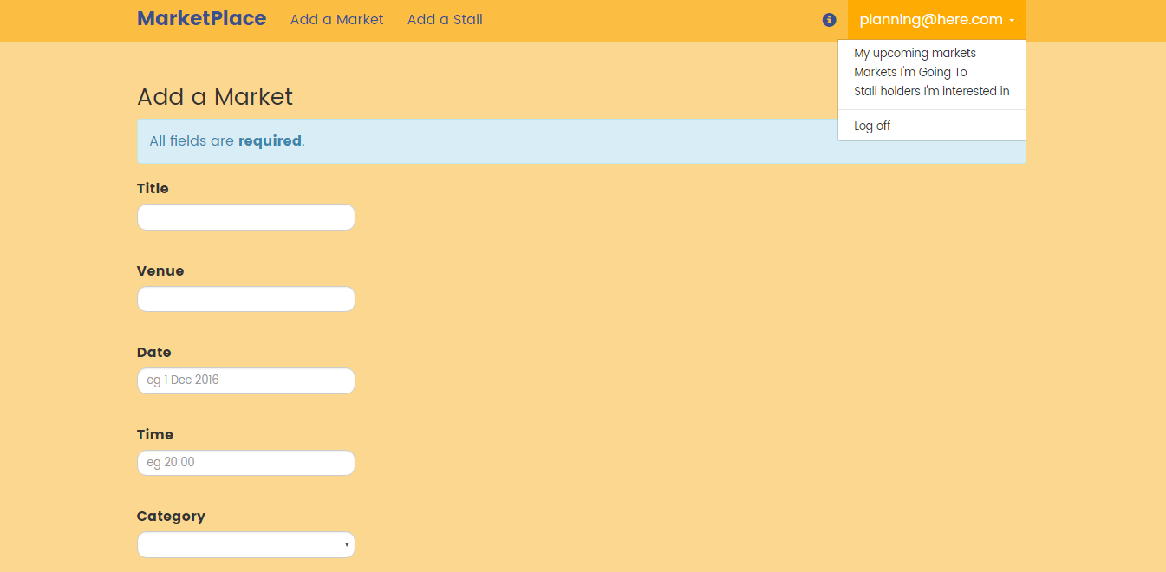
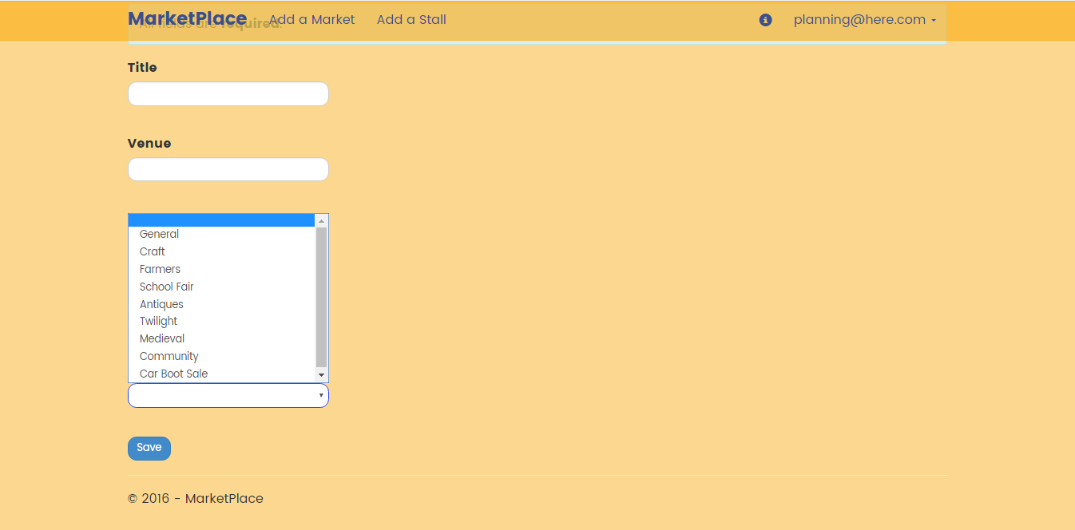
This step involved learning to create a dropdown list, changing the appearance of the form by using Bootstrap to add curves, types of buttons and the general look and feel of the form.
It also involved learning about how to implement validation so that the database was protected from corruption.
Once the database was created, several views were created to present the information for different purposes
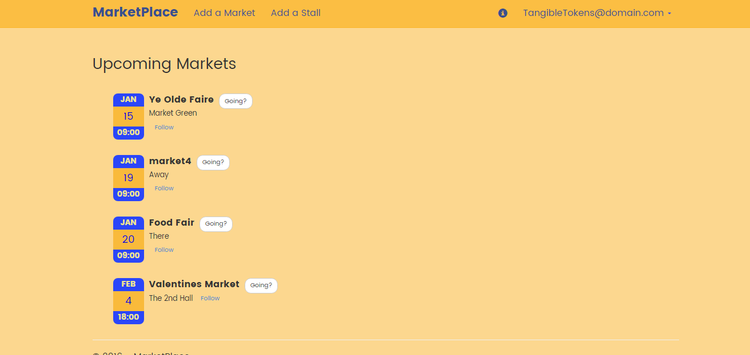
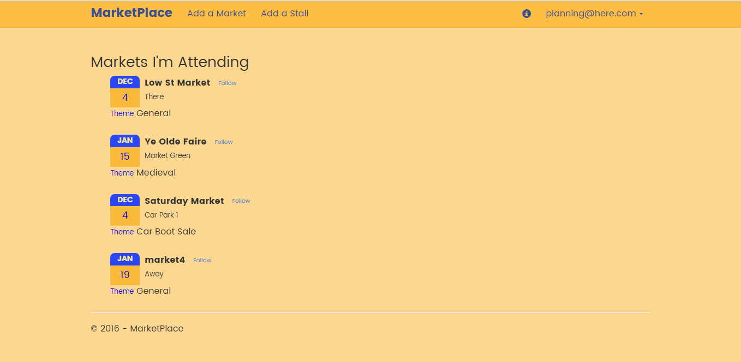
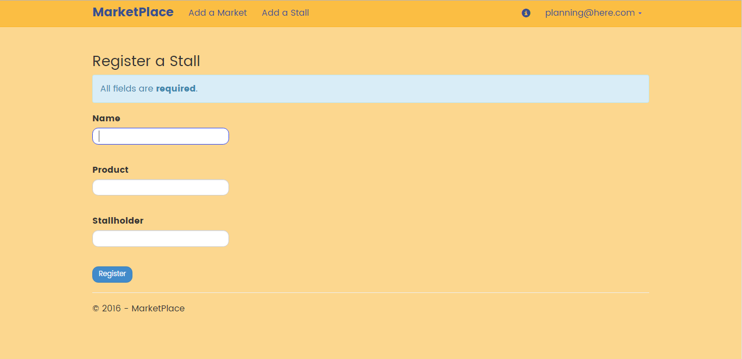
At this stage I also wrote the code to add a stall holder to the database though, as of writing this, I have not connected them to a market and so they are not displayed anywhere except in the table on the database. Registration as a stall holder is the same as for any other and at this stage, registering a stall occurs via the navigation bar.

This will eventually be moved to a button on a page that will display only the details of a selected market. This is still to come. For now, the information is safely tucked away in the database. (Well, one is!)
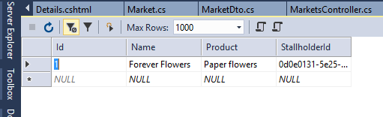

I have also written code to display more details for the markets, but as yet, havent discovered how to tie the view to a button click.

Next came the process of writing the code to allow for updating the market information or deleting a market. This entailed using CSS to create labels that would be displayed when the mouse hovered over them.
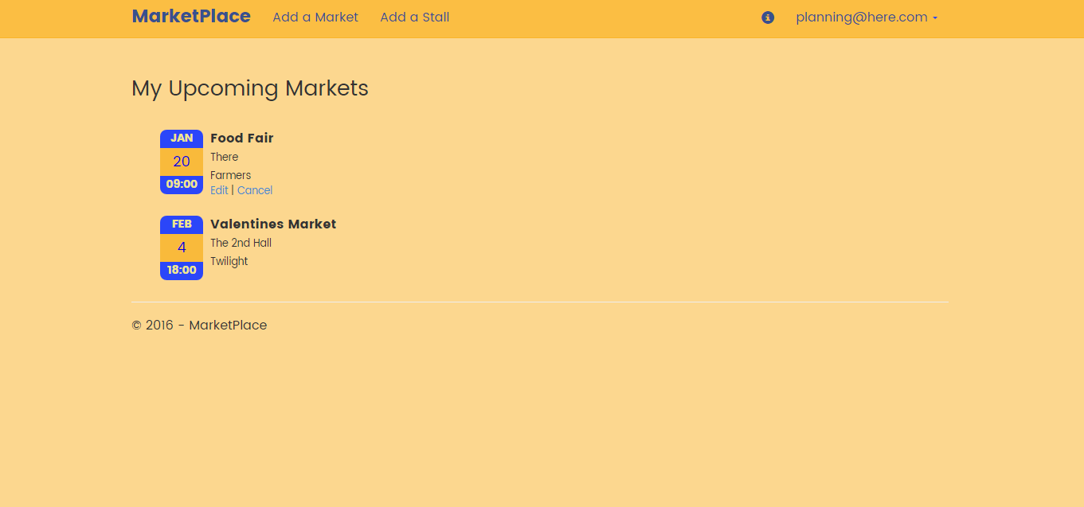

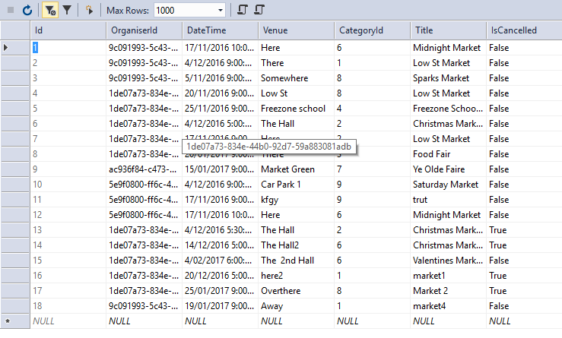
Both functions worked well until I began to include notification facilities and so there is a bit of a glitch which I haven’t yet been able to fix.
Edit function used here.

Delete, here.
Overall, although this project is not yet able to do all that it eventually will, it is well on the way. It is just a matter of working out how to display different information, which is coming – its only writing search queries! (and then displaying them in views) and learning my way around JQuery.

Overall, I think this project was a success. I was able to use the skills I had developed over the year, not only in the coding but also in team work, research and perseverance!

